Lab 2-3



Name:
M.Zain Ul Abideen
Reg No:
FA22-BCS-090
Subject:
Compiler Construction

Submitted to:
Mr. Nasir Mehdi

Compiler Construction
Lab 2

Lab Activity 1:
This activity demonstrates the removal of extra white spaces:

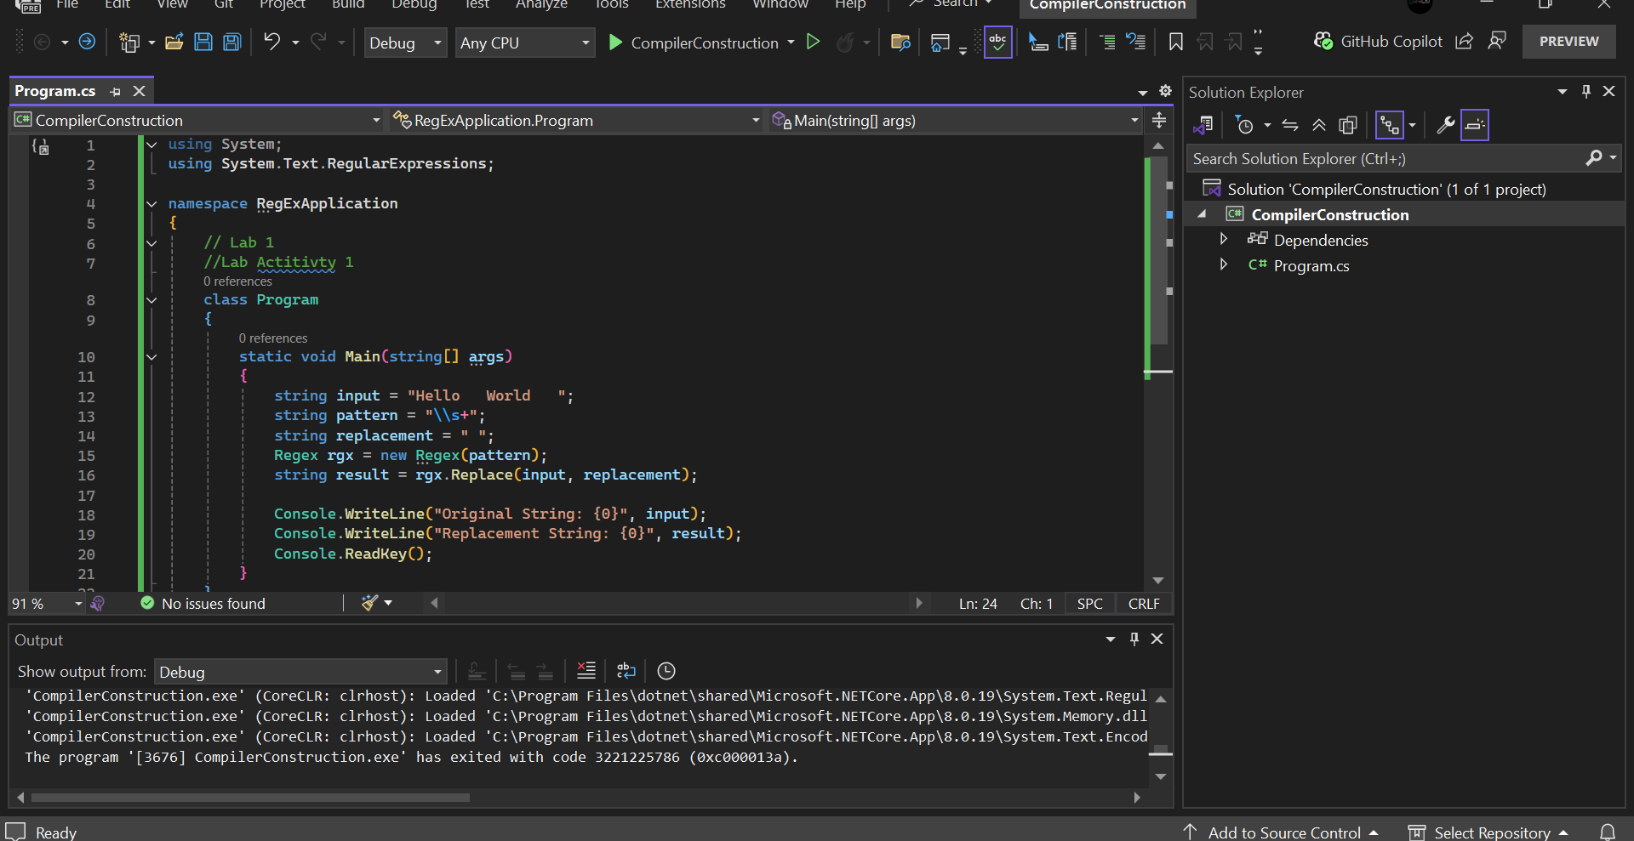
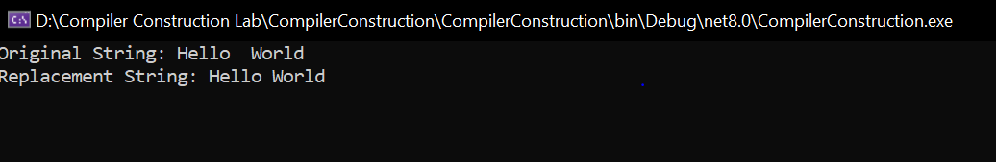

Lab Activity 2:
Design regular expression for arithmetic operators: Regular Expression for operators: [+|*|/|-]
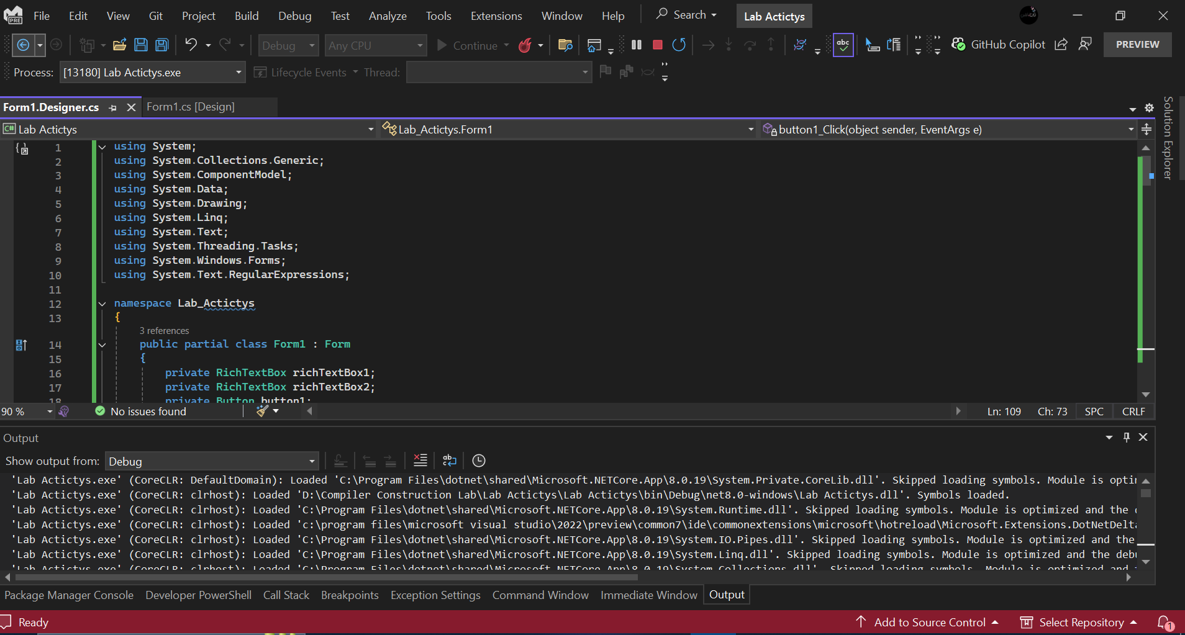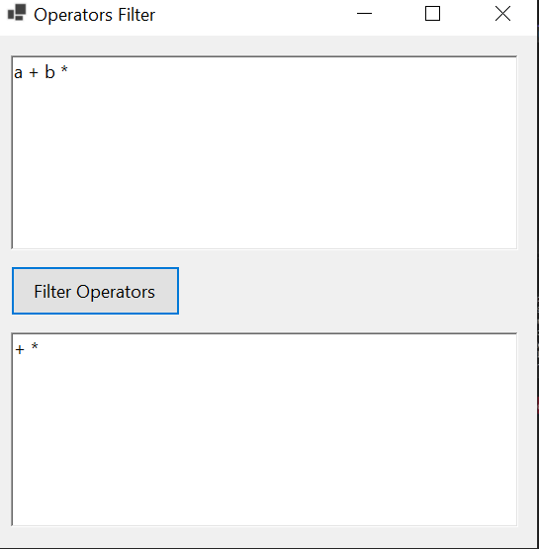

Activity 3:
Any meta character with special meaning may be quoted by preceding it with a backslash. In basic regular expressions the metacharacters "?", "+", "{", "|", "(", and ")" lose their special meaning; instead use the backslashed versions "\?", "\+", "\{", "\|", "\(", and "\)".
Regular Expression for variables is: [A-Za-z]([A-Za-z|0-9])*
Design a regular expression for variables that should start with a letter, have a length not greater than 10 and can contain combination of digits and letters afterwards.
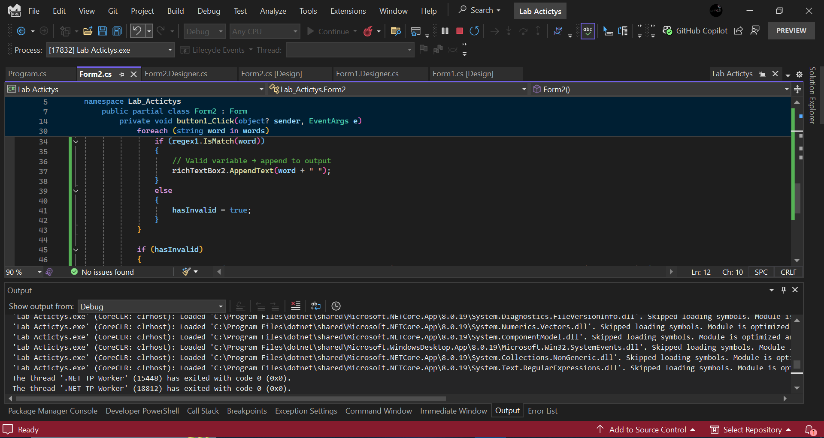
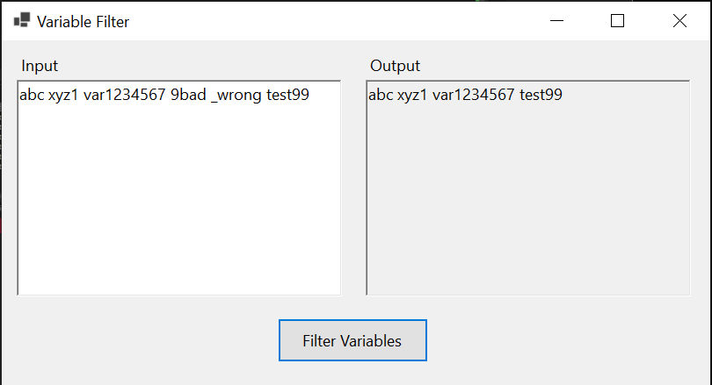
Lab 03
Activity 1:
Design a regular expression for constants (digits plus floating point numbers): Regular Expression for Constants: [0-9]+((.[0-9]+)?([e][+|-][0-9]+)?)? Using Datagrid view.
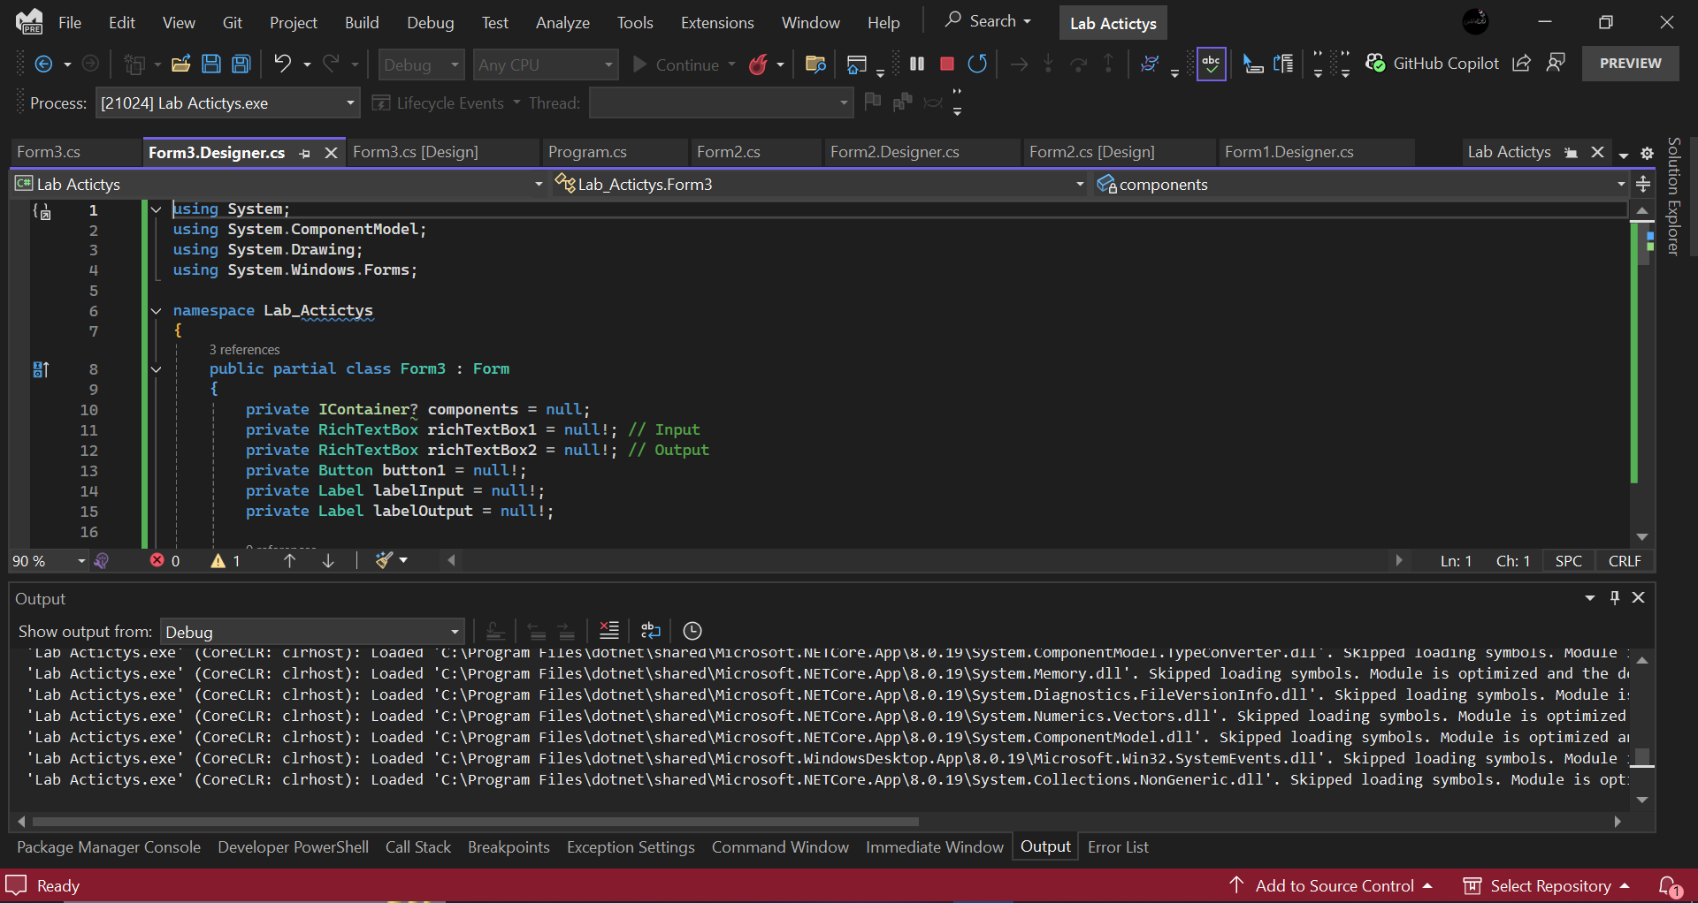
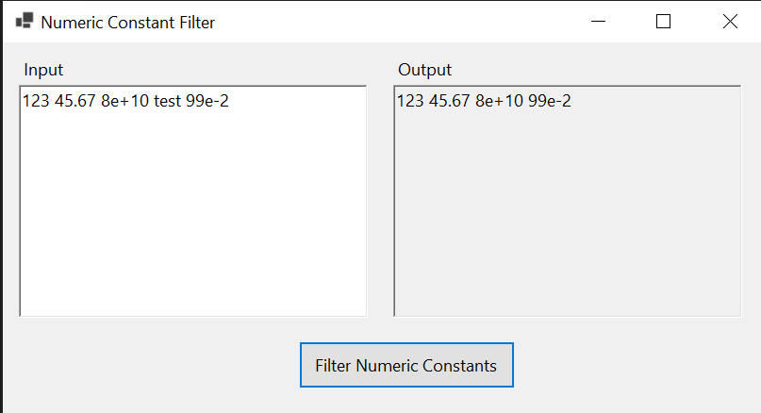

Activity 2:
Design a regular expression for keywords.(Using Datagrid view). Regular Expression for keywords:[int | float | double | char]
